You can only feel!

The educator Alex Garcia - a deafblind person - developed his 2nd meeting in the "Lato Sensu" course in Specialist in Educational Service - ESA, in the city of Itaqui - RS, with the subject of Special Education: Deafblind - 15 hours, promoted by SEG, on 16 and 17, October, 2015.

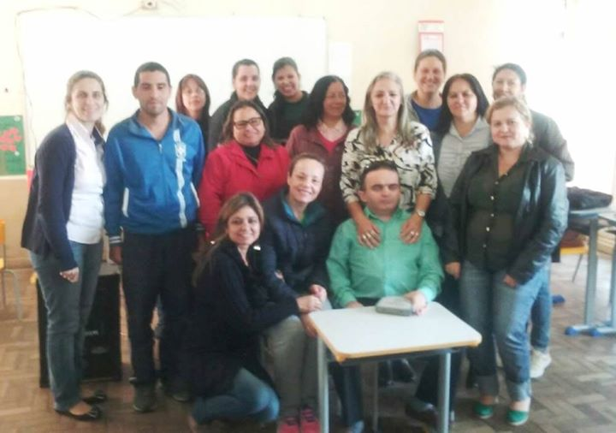

Alex Garcia highlights: I feel accomplished in supporting SEG again. Acting side by side academic students who live inside in the countryside is fascinating. small towns, humble people, but with great intelligence.

The Students pointed out:

“I believe it was something new and an experiences that I had never really reflected about. I would like to congratulate you for the class and mainly to say that you are a winner, an example for everyone. I believe that we evolved not only in the academic part in which the task of the special educator is wide and the struggle to break barriers is very important to break paradigms. Analyzing this academic subject in as the subject in the teaching and learning process, we can highlight the environment for our reflections. The search for the school everyday improvement and the target public. I believe that the subject brought new techniques to our students’ approach, breaking with traditional models and respecting diversity and particularity that involves the public with disabilities. Within opportunity to exchange knowledge in discussions with” colleagues” and a professor of such an importance to our personal and professional growth”.

“The discipline of deafblindness in the "Lato Sensu" course in Specialist in Educational Service - ESA, backed up in the key concepts approach to issues of deafblind student's theoretical knowledge and practical. Methodology of how to deal with this target public. In this sense, we had the dimension of the particularities surrounding the educational process, bringing forth reflection, analysis and discussion of cross-cutting issues of human and school routine. Superb !!!!”

"Hello, Professor Alex! I believe that there are some things in life that are not possible to be measured and the subject of deafblindness, given by you is one of these things. It is not possible, for me, to evaluate with numbers or words what you can only feel. And yesterday and today, during your classes, it was indescribable what we felt: For all the knowledge that you efficiently shared with us and for your wonderful testimony of life, as well for the example of dedication and commitment of your parents. You proved that, if you believe, everything is possible. And that your fight, instead of accommodation because of your disability, you have opened minds and doors everywhere you have been. Places that have been graced by your presence and by your “unforgettable” words. All of us from the Inclusive Education course, in Itaqui, can only thank God for such a grace to have met, listened and learnt from you. We hope to have other opportunities to meet you again, because everything that is very good will be missed and we want to have you back to our city. Maybe one day, you can come with your family? All the best for you and I wish you can continue doing this amazing work all over the world because there are no limits for your willing of teaching . Congratulations”.

“Hello, professor! At first we new your classes would be different and would move us, and it was exactly what happened. Your work is fascinating and the way you approached the topics, bringing us to experiences, you provided us a deeper practical-theoretical knowledge. We miss you already !!!!!”

“The classes about deafblindness, given by Professor Alex, on October, 16 and 17, 2015, being the last subjects at the "Lato Sensu" course in Specialist in Educational Service - ESA-group 1- in the city of Itaqui – RS, were really unforgettable such as the professor had saiud they would be. The university course was the bureaucratic part of Professor Alex’s life. Through experiences, through his life, he learnt much more. He is the only deafblind person in Brazil (and one of few people in the world) who has this work: he teaches, lectures, is the president of an association, writes books, advises families of deafblind persons and he gives you all you need to keep fighting“.

About SEG - The SEG is an education system dedicated to training professionals for the labor market - www.estudeseg.com.br

Warm regards from Brazil !

Alex Garcia - Deafblind Brazilian
www.agapasm.com.br/alexgarciaing.asp

